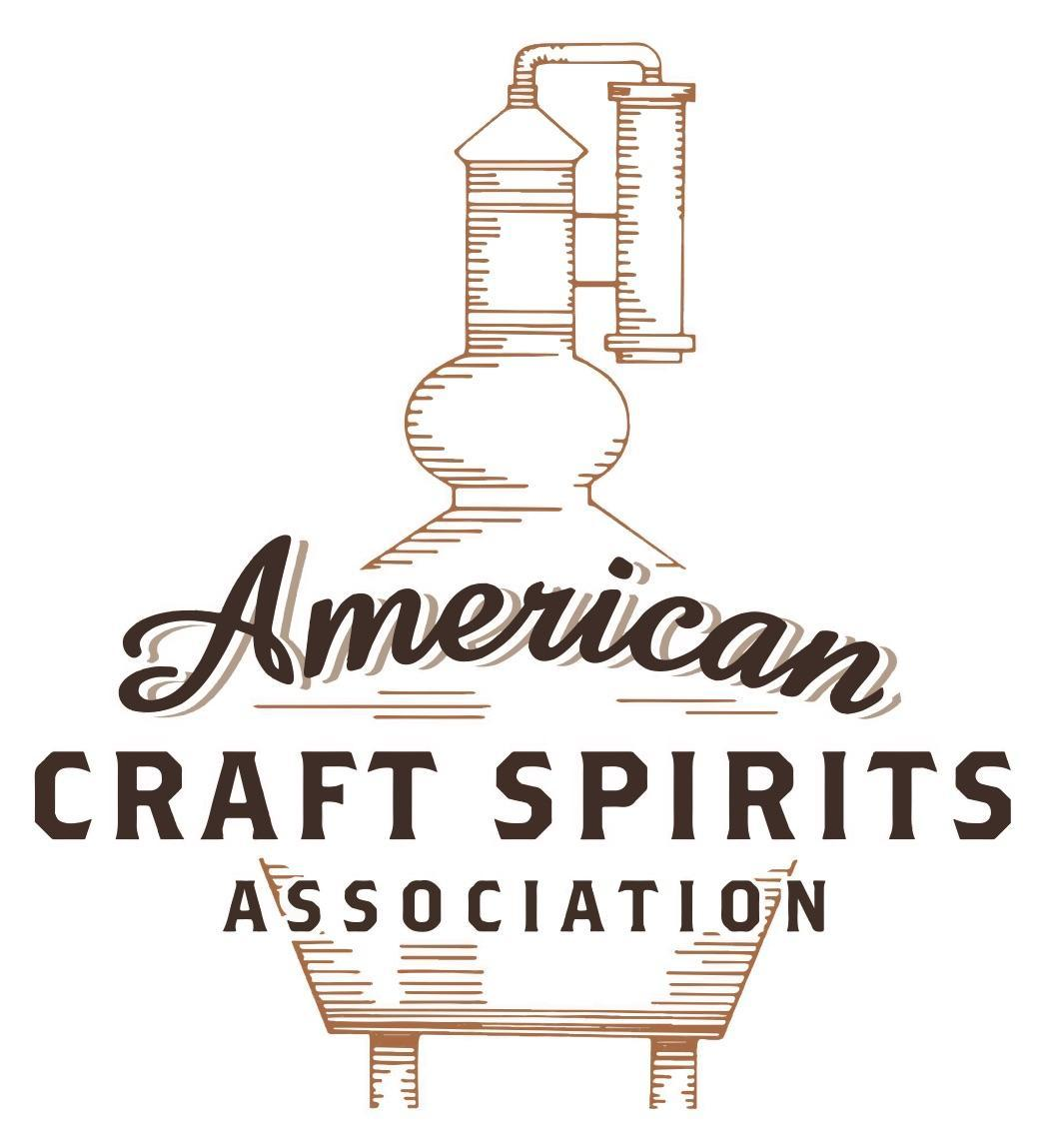
Spirits DtC Shipping Guide

This guide summarizes the direct-to-consumer shipping rules for distilleries in all 50 states and D.C. and also addresses the measures state governments have taken to ease delivery and shipping restrictions during the COVID-19 pandemic.

DtC Quick Guide Comparison

Out-of-State Distilleries  Can Ship Into State? |  |  |  | In-State Distilleries  Can Ship Within State?
State | Yes | No |  | State | Yes | No
AL |  | X |  | AL |  | X
AK | X |  |  | AK | X
AZ | X |  |  | AZ | X
AR |  | X |  | AR |  | X
CA |  | X* |  | CA |  | X*
CO |  | X |  | CO |  | X
CT |  | X* |  | CT |  | X
DE |  | X |  | DE |  | X
DC | X |  |  | DC | X
FL |  | X |  | FL |  | X
GA |  | X |  | GA |  | X
HI |  | X* |  | HI |  | ?*
ID |  | X |  | ID |  | X
IL |  | X* |  | IL |  | X*
IN |  | X |  | IN |  | X
IA |  | X* |  | IA |  | X*
KS |  | X |  | KS |  | X
KY | X |  |  | KY | X
LA |  | X |  | LA |  | X
ME |  | X* |  | ME |  | X*
MD |  | X |  | MD |  | X
MA |  | X |  | MA |  | X
MI |  | X |  | MI |  | X
MN |  | X |  | MN |  | X
MS |  | X |  | MS |  | X
MO |  | X |  | MO |  | X
MT |  | X |  | MT |  | X
NE | X |  |  | NE | X
NV |  | X* |  | NV |  | X
NH | X |  |  | NH |  | X*
NJ |  | X* |  | NJ |  | X*
NM |  | X |  | NM |  | X
NY |  | X* |  | NY |  | X*
NC |  | X |  | NC |  | X
ND | X |  |  | ND | X
OH |  | X |  | OH |  | X
OK |  | X |  | OK |  | X
OR |  | X |  | OR | X
PA |  | X* |  | PA |  | X
RI |  | X* |  | RI |  | X
SC |  | X |  | SC |  | X
SD |  | X |  | SD |  | X
TN |  | X |  | TN |  | X
TX |  | X |  | TX |  | X
UT |  | X |  | UT |  | X
VT |  | X |  | VT |  | X
VA |  | X |  | VA |  | X
WA |  | X* |  | WA | X
WV |  | X* |  | WV |  | X*

WI |  | X |  | WI |  | X
WY |  | X |  | WY |  | X

Notes:
*CA: If passed and signed into law, Senate Bill 620 would allow licensed distilled spirits producers in states other than California and licensed distilled spirits manufacturers or craft distillers in California who obtain distilled spirits direct shipper permits to ship directly to consumers in California
*CT: Consumers with appropriate permit may receive alcohol shipments
*HI: Consumers with appropriate permit may receive alcohol shipments; If passed and signed into law, Senate Bill 65 would allow licensed distilled spirits manufacturers in Hawaii and in states other than Hawaii who obtain direct shipper permits to ship directly to consumers in Hawaii
*IL: If passed and signed into law, Senate Bill 0532 would allow licensed distilled spirits producers in Illinois and in states other than Illinois who obtain distillery shippers’ licenses to ship directly to consumers in Illinois
*IA: If passed and signed into law, House File 639 would allow native distilled spirits manufacturers in Iowa and in states other than Iowa who obtain direct shipper permits to ship directly to consumers in Iowa and to consumers in states other than Iowa
*ME: If passed and signed into law, Legislative Document 1358 would allow distilleries outside of Maine with current manufacturer licenses and distilleries licensed in Maine who obtain spirits direct shipper licenses to ship directly to consumers in Maine
*NJ: (1) If passed and signed into law, Assembly Bill 3167 would allow a craft distillery licensees to ship no more than 9 liters of distilled spirits to a consumer in New Jersey; (2) If passed and signed into law, Senate Bill 3020 would allow craft distillery licensees in New Jersey or in states other than New Jersey to ship no more than 20 liters of distilled spirits to a consumer in New Jersey via common carrier
*NV: Licensed individuals can import one gallon per month of spirits for personal use and the out-of-state supplier must pay excise tax
*NH: If passed and signed into law, Senate Bill 125 would allow licensed liquor manufacturers who obtain direct to consumer shipping permits from the commission to ship directly to consumers in New Hampshire
*NY: Consumer may import up to 90L of liquor per year for personal use without a license; If passed and signed into law, Assembly Bill 3275 would allow licensed liquor manufacturers in states other than New York and licensed distillers and farm distillers in New York to ship no more than thirty-six cases (no more than nine liters per case) of liquor to consumers in New York
*PA: Consumer may place a special liquor order and distiller must ship to a PLCB-operated store
*RI: Distiller can only ship to customer if order was personally placed by customer at distiller's premises
*WA: If passed and signed into law, House Bill 1432 would allow licensed spirits manufacturers in states other than Washington to ship spirits to consumers in Washington
*WV: Distilleries, mini-distilleries, or micro-distilleries licensed in West Virginia or a state other than West Virginia who obtain private direct shipper licenses to ship to a consumer in West Virginia, however the shipments must be made to a retail liquor outlet

PENNSYLVANIA
Shipment Outbound – Silent.
Shipment Inbound – No, however, a consumer may place a special liquor order (“SLO”) and the manufacturer must ship the order to a PLCB-operated wine and spirits store. However, delivery may only occur after payment has been forwarded to the PLCB and the PLCB has authorized delivery of the order. The PLCB is permitted to refuse to process, or prohibit the processing of SLOs for items that are substantially similar to items that appear on its monthly price lists or if the PLCB believes demand for the items warrants them being made available generally (See below PA Liquor Control Board information regarding shipping alcohol into PA).
Shipment Intra-state – No, limited distilleries and distilleries have various license options that allow consumers to buy from the distiller, but sales must occur on a licensed premise (47 P.S. § 5-505.4).
COVID-19 Measures – Licensees allowed to sell mixed-drinks on premises were allowed to sell those to-go. As of June 15, 2021 (when the emergency declaration was terminated), pre-pandemic rules apply. Distilleries/limited distilleries were always allowed to sell their own alcohol for off-premises consumption.
Act 21 of 2020 Link: https://www.legis.state.pa.us/cfdocs/legis/li/uconsCheck.cfm?yr=2020&sessInd=0&act=21
What Licensees Should Know About Act 21 of 2020 Link:
https://www.lcb.pa.gov/Legal/Documents/Act%2021%20of%202020%20PLCB%20FAQs.pdf
Guidance for Licensees in All Counties Link: https://www.lcb.pa.gov/Legal/Documents/Guidance%20for%20all%20Counties%20(June%2024,%202021).pdf
Citation (shipment)
Pennsylvania Statues
47 P.S. § 5-505.4. Limited distilleries and distilleries
(b)(1) The board may issue a limited distillery license that will allow the holder thereof to operate a distillery that shall not exceed production of one hundred thousand (100,000) gallons of distilled liquor per year. The holder of the license may manufacture and sell bottled liquors produced on the licensed premises to the board, to entities licensed by the board and to the public between the hours of nine o'clock antemeridian and twelve o'clock antemeridian Monday through Saturday and Sunday between the hours of nine o'clock antemeridian through eleven o'clock postmeridian so long as a specific code of distilled liquor which is listed for sale as a stock item by the board in State liquor stores may not be offered for sale at a licensed limited distillery location at a price which is lower than that charged by the board and under such conditions and regulations as the board may enforce. The holder of a limited distillery license may not sell a product or a substantially similar product which is listed for sale as a stock item by the board in State Liquor Stores to a licensee at a price which is lower than that charged by the board and under such conditions and regulations as the board may enforce. The holder of a limited distillery license may also sell wine, alcoholic cider and fermented fruit beverages produced by a licensed limited winery, liquor produced by a licensed distillery or limited distillery and malt or brewed beverages produced by a licensed brewery for on premises consumption. The combined sales of wine, malt or brewed beverages and liquor produced by another licensed distillery or limited distillery may not, on a yearly basis, exceed fifty per centum of the on-premises sales of the limited distillery's own sales of liquor for the preceding calendar year: however, if a limited distillery did not operate for an entire calendar year during the preceding year, then its combined sales of wine, malt or brewed beverages and liquor produced by another licensed distillery or limited distillery may not, on a yearly basis, exceed fifty per centum of the on-premises sales of the limited distillery's own liquor for that year.
(2)(i) The holder of a limited distillery license may, separately or in conjunction with other limited distillery licensees, sell bottled liquors produced by the distillery at no more than five (5) board-approved locations other than the licensed premises, with no bottling or production requirement at those additional board-approved locations and under such conditions and regulations as the board may enforce to the board, to individuals and to entities licensed by the board.

Further retail sales allowed, please see statute.
Link: https://govt.westlaw.com/pac/Document/NB22AC99015F911EAB67AB4E65B51823F?viewType=FullText&originationCo%20ntext=documenttoc&transitionType=CategoryPageItem&contextData=(sc.Default)
PA Liquor Control Board
Updated 09/2017
RULES WITH REGARD TO SHIPPING ALCOHOL INTO PENNSYLVANIA FROM OTHER STATES
It is unlawful for any person to import alcohol into Pennsylvania except as permitted within the Liquor Code and the PLCB’s Regulations. 47 P.S. § 4-491(8), (11). The law provides that:

It shall be unlawful [f]or any person, other than the board or the holder of a sacramental wine license, an importer's license or a direct wine shipper's license, to import any liquor whatsoever into this Commonwealth.

47 P.S. § 4-491 (11).
Therefore, unless the recipient of the liquor falls within one of the four exceptions provided in section 491(11) – the PLCB, a sacramental wine licensee, an importer, or a direct wine shipper – such importation of liquor is illegal.
In addition, liquors and wines not listed for regular sale through the PLCB’s wine and spirits stores may be acquired by residents of the Commonwealth (including licensees of the PLCB) via special liquor order (“SLO”). 47 P.S. § 3-305. SLOs may be placed at any of the PLCB’s wine and spirits stores, or via the Bureau of Product Selection at (800) 332-7522, option # 1. SLOs placed by a consumer must be shipped to a wine and spirits store operated by the PLCB and may be either for personal use or, if purchased by a PLCB licensee, for resale in any licensed establishment. Such liquor is subject to taxes, a markup of 10% of the product, freight/shipping charges, and a handling fee.
Act 39 also allows the PLCB to accept SLOs placed by licensed importers or licensed vendors on behalf of customers, in addition to accepting SLOs placed directly by customers. However, delivery may only occur after payment has been forwarded to the PLCB and the PLCB has authorized delivery of the order. Liability for SLOs placed by licensed importers or licensed vendors on behalf of customers remain with the importer or vendor until the time of delivery to the customer.
The PLCB is permitted to refuse to process, or prohibit the processing of, SLOs for items that are substantially similar to items that appear on its monthly price lists, or if the PLCB believes demand for the items warrants them being made available generally. The PLCB has the discretion to determine the amount and manner for which any such item will be made available.
Link: https://www.lcb.pa.gov/Legal/Documents/000820.pdf

The American Craft Spirits Association (ACSA) is working diligently to give our members and industry partners relevant, current updates on statutes and regulations impacting production, sale and distribution of spirits. With the declaration of the novel coronavirus (COVID-19) in early 2020, many states have issued temporary policy changes or longer-term modernization of alcohol beverage laws. State statutes, regulations created by the state alcohol regulatory authority, as well as any other relevant guidance provided by such authorities (such as advisories, opinions, bulletins, etc.) were reviewed in creation of this document. No city or county ordinances were reviewed. Distillers should be aware that even in states where direct shipping is permissible, always remember to avoid shipping to dry counties. Please consult with your state guild or alcohol beverage authority for the most up-to-date information. This content is intended for educational and informational purposes only. ACSA's pro bono law firm of Malkin Law P.A. provided the core content found in this comprehensive overview of the spirits distribution after COVID-19. It was completed in August 2021 and will be updated regularly. If you have updates you would like to provide, please send to legislation@americancraftspirits.org or directly to the law firm at: ryan@malkin.law / malkin.law. Thank you.
H.B. 1154, introduced on April 12, 2021, would allow a restaurant licensee, hotel licensee, and distributor licensee to sell ready-to-drink cocktails for off-premises consumption in quantities of not more than one hundred ninety-two fluid ounces in a single sale to a consumer. The bill is in committee. Link: https://www.legis.state.pa.us/cfdocs/legis/PN/Public/btCheck.cfm?txtType=PDF&sessYr=2021&sessInd=0&billBody=H&billTyp=B&billNbr=1154&pn=1210

